Tabs

Tables

* Required
  + Resizable columns  
    <hover over separation changes mouse and can click and drag to resize>
  + Sorting  
    
    - Ideally this can distinguish numeric vs alphabetical sorting
  + Filtering (currently per column, multiple columns)  
    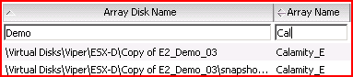
  + Right click context menus (cell-based)  
     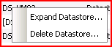
  + Hide columns  
      
    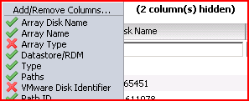
  + Hide duplicates (Hide identical vertically adjacent cells – used in View All table)  
    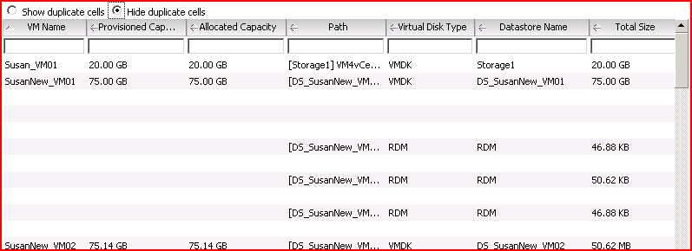
  + Export as csv or similar format  
    
  + Tooltip for column headings to provide description  
    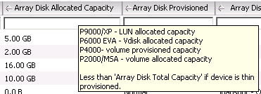
  + Horizontal and vertical scrolling  
    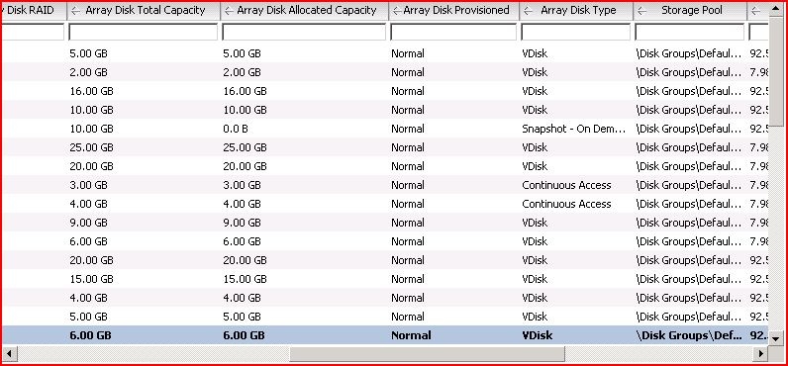
  + Row selection  
    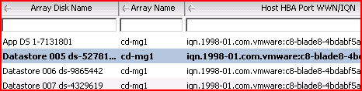
  + Fixed Header/Filter
    - Header and filter doesn’t scroll off the page
  + Cookies to store user changes to tables - Per table per ObjectType (i.e. Host, VM, Datastore, cluster, …)
    - Visible columns
    - Column width
* Nice to have
  + Reorder columns

Right click context menus

* Currently in tables only

Horizontal Stacked Bar chart

* (Used to show thin provisioning savings)

Pie chart

* Used to show provisioning information

Graphic

* Display an image (i.e. gif or jpg).

Tooltip

* (to show more detail)